NYC
9/11 Memorial Field
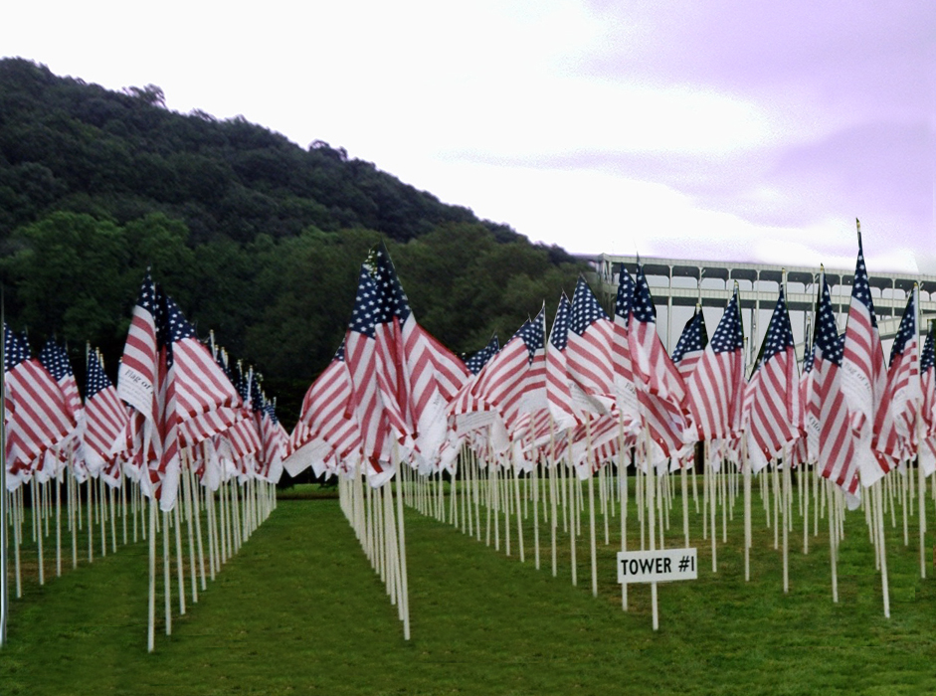
Manhattan’s Inwood Hill Park
September 8 – 11, 2006

Fifth Anniversary Memorial Event
for the Entire NYC Community
www.nyc911memorialfield.org

Contact information
Mike Hughes John Michelotti
NYC 9/11 Memorial Field Flag of Honor Fund
PO Box 343 Phone 203-863-9161
New York, NY 1003 Cell – 203-273-0331
Cell - 917-523-3754

NYC 9/11 Memorial Field Preliminary Timeline
Event Timeline
Date | Time | Activity
Friday September 8 | 12pm -10pm | Site open to public
 | 1pm | Dedicate Field
 | 1pm - 4 pm | School visits
 | 10pm | Site closes to public
Saturday September 9 | 8am-10pm | Site open to public
 | 10am-6pm | Displays-FDNY, NYPD, PAPD, EMS, US Armed forces
 | 12pm | Harley Davidson Tri State Chapters Motorcycle Parade
 | 6pm | Evening Music
 | 9:00pm | Laser Light Show
 | 10pm | Site closes to public
Sunday September 10 | 8am-10pm | Site open to public
 | 8am-10pm | Displays-FDNY, NYPD, PAPD, EMS
 | 2pm | Event Ceremony
 | 6pm | Evening Music
 | 10pm | Site closes to public
Monday September 11 | 8am-8pm | Site open to public
 | 8:30am-10:30am | Moments of silence
 | 6pm | Taps
 | 10pm | Site closes to public
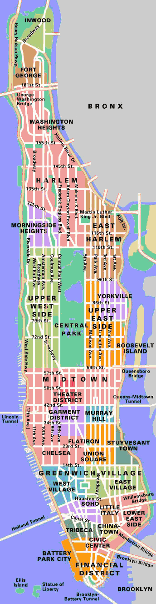

Inwood Hill Park
218th St. and Indian Road
Directions:
By car: From the West Side Highway. Take the Dyckman Street exit. Follow the exit as it merges with Broadway. Drive North on Broadway to 218th Street. Take a left on 218th Street and drive west on 218th Street. The entrance to the park is at the end of the street. The Nature Center is located in Inwood Park. Take the FDR/East River Drive north to end. The end of the highway is at Dyckman Street. Bear left on Dyckman Street. Take Dyckman west to Broadway, and take a right on Broadway. Proceed north to 218th Street and make a left turn. The entrance to the park is at the end of 218th Street.

Public transportation: Take the 1 or the 9 train to the 215th Street stop. Walk North to 218th Street. Take a left and walk on 218th Street. The entrance to the park is at the end of the street.
OR
Take the A train to 207th Street. If you are in the last car of the train (near the handicap elevator), proceed west to Seaman Avenue, then north to Isham Street. If you are in the first car of the train, you will exit onto Isham Street. Go west to Seaman Avenue and proceed north into the park

