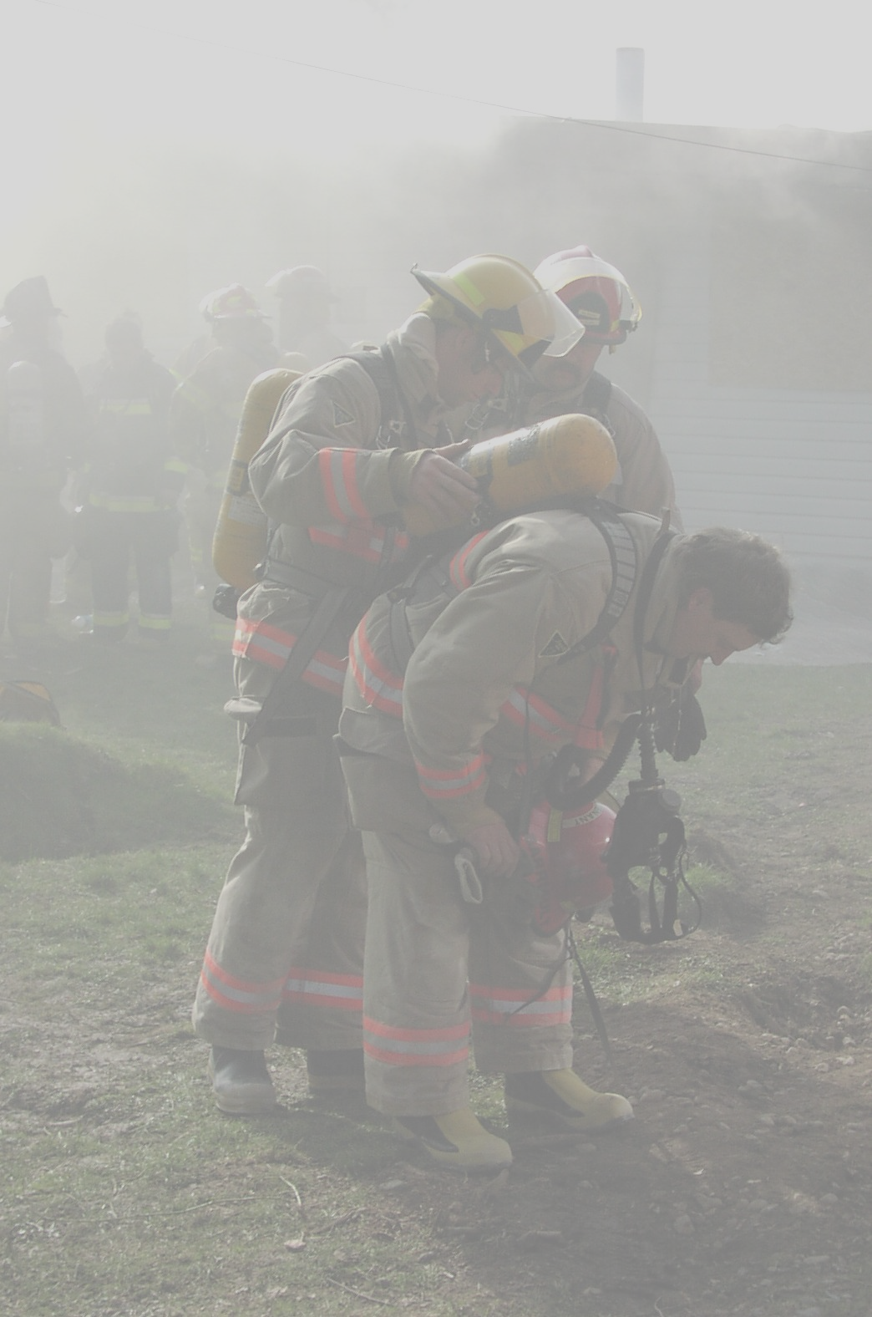
Dear God…..

Embrace each flame burning deep
within that answers the 911 call.
Enrich us with your wisdom, nurture us,
heal us, provide a safe place to fall.

Through these weathered eyes may our
families recognize the depth of our love.
Bring peace to our tired hearts and
give hope to all we are dreaming of.

Allow us the joy of attaining the highest
good in pursuit of what really matters.
Help us be accountable whether we are
taking a hydrant or climbing the ladder.

Renew the vow from leadership to serve
and protect those working from the firehall,
So that we make informed decisions having
all the tools to safely return from every call.

Let us walk without fear, courageously
inviting an abundance for living.

Blessed through our service to humanity, may we
cherish our oath and be fulfilled by what we are giving.

No matter what rank we have achieved when
the situation goes from bad to worse,
I pray that each of us has earned the right to
be remembered as being a firefighter first.

Encourage gratitude as we look above to all the
smiling faces filled with compassion and pride,
Strengthening each firefighter until the end, comforting
us in knowing they will be waiting…….arms open wide.

We are heroes moving through life as a worldwide
fraternity existing beyond time and measure,
An unbreakable dynamic caressed by love and an uncommon
understanding so unique it will live on forever.

God bless us and keep our family safe.

© Mary E. Feldman, March 11, 2002

