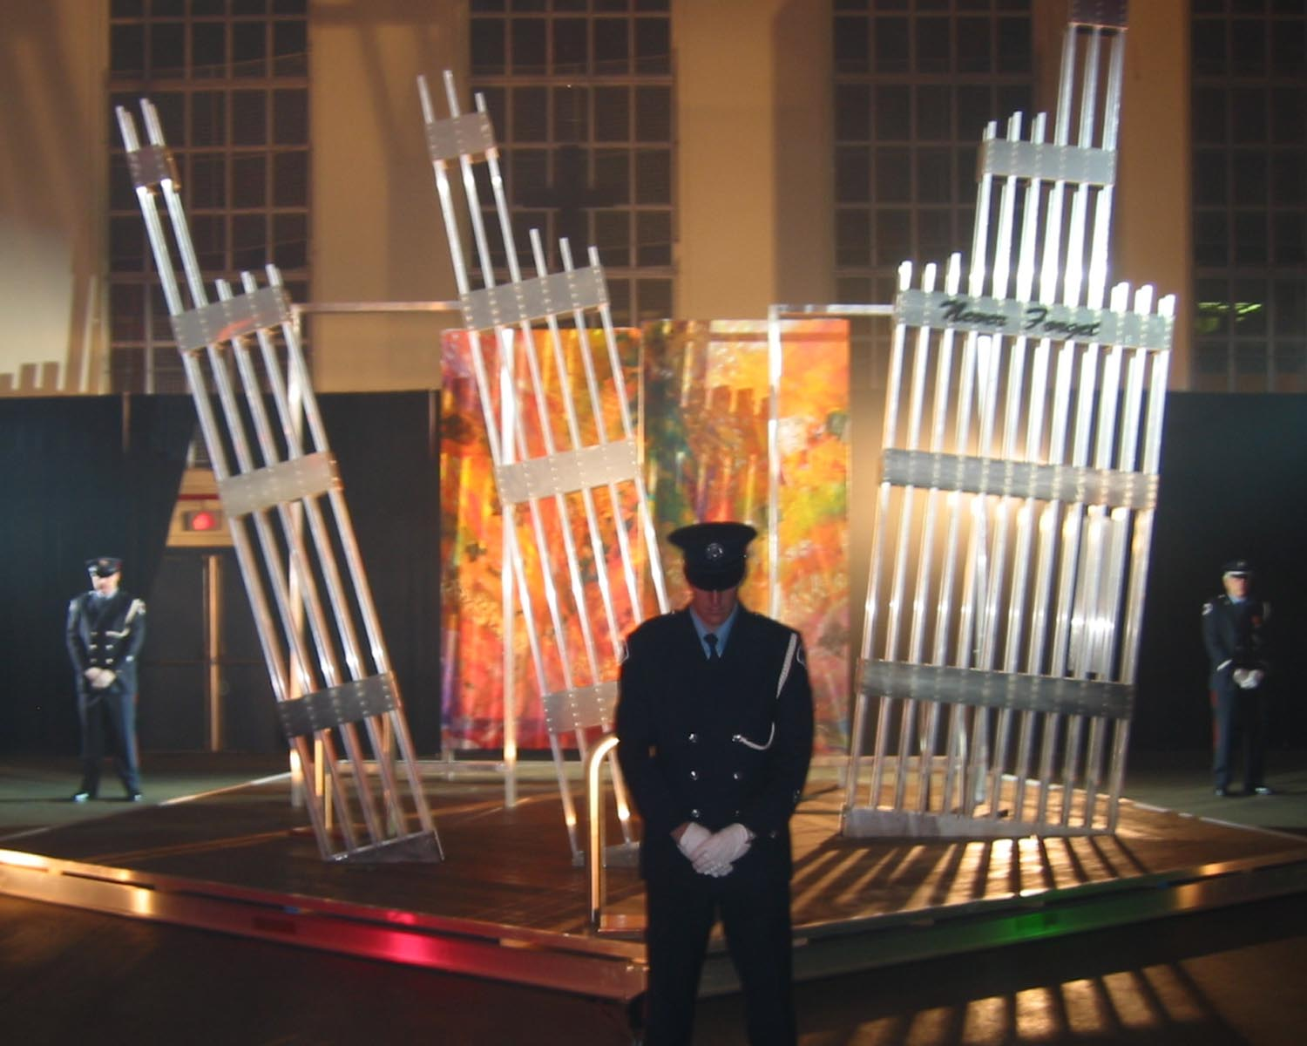

November 07, 2003

Seaforth Highlanders of Canada Armoury

Opening Ceremonies Order of program
7:30pm

Welcome

Master of Ceremonies - Tom Walker

Vancouver Fire Fighters Honour Guard

USA Anthem
15th Field Artillery Regiment Band
Vocals - Glenda Rae

Canadian Anthem
15th Field Artillery Regiment Band
Vocals – Fiona Blackburn

Laying of wreaths and attaching of names
Tom Walker will introduce wreath layers:
American Airlines Pilot, Brus Messinger from Texas
Air Canada Flight Attendant, Maureen Basnicki

WTC Canadian Widows from Toronto, Maureen Basnicki and Tanja Tomasevic

Seaforth Highlanders of Canada Lone Piper will Pipe as the USA and Canadian wreaths are laid at the 9/11 Memorial

Names of Canadians, Ken Basnicki and Vladimir Tomasevic will be attached to the Surviving Wall

Children are the Healers of the World
Vocals – Janina Maria Russell
Flute – Yurgen Ilander
The Childrens Rainbow Singers

Taps
International Association Fire Fighters Local #18
Vancouver Vice. President, Joe Foster

Guest speakers
Vancouver Acting Deputy Mayor, Peter Ladner
Canadian National Defence, Captain Dan Thomas
American Airlines Pilot, World Memorial Founder, Brus Messinger
Air Canada Flight Attendant, Maureen Basnicki

First Flight
15th Field Artillery Regiment Band

Guest speakers
Vancouver Fire Chief Ray Holdgate
Vancouver Port Authority, Captain Chris Badger

Seaforth Highlanders of Canada Pipe Band
Red carpet march

Guest speaker
International Association Fire Fighters’ Local #18,
Vancouver Vice President, Joe Foster

O’Danny Boy
Vocals – Vancouver Fire Fighter / Opera singer, Andy Greenwood

Prayer
Maple Ridge Fire Chaplain, Dan Ost

Sands of Kuwait
15th Field Artillery Regiment Band
Seaforth Highlanders of Canada Pipe Band
Maple Ridge Symphony Orchestra

Band introduction:
Miles Black, Rene Worst, Brett Wade, Tony Chamberlist

Faith
Glenda Rae

Not Afraid
Glenda Rae

When Daddy Comes Home
Fiona Blackburn

Mull of Kintyre
Fiona Blackburn

Iris Messinger introduction:
Iris Messinger, Viola, Eastman School of Music, New York

Pat Armstrong introduction:
Pat Armstrong, 1st Violin, CBC

Family To Me
Glenda Rae

Darkest Night
Glenda Rae

Anniversary Song
Fiona Blackburn

Release of Souls
Fiona Blackburn

Release of Souls Team introduction:
Dave Rouleau, Dave’s Custom Metal Works
Brian Lytton, Peak Engineering Ltd.
Louis Louw, Architectural design
Katon, Artist

Thank You
Kathleen Tonnesen

Scotland the Brave
Seaforth Highlanders of Canada Pipe Band

Release of Souls – Katon

Inspiration

Due to my sister Christine’s death, I realised the physical pain and depression one endures and the absolute agony of grief. How people expect you to pull yourself together and “Get over it”. But the reality is, that healing can only occur one small step at a time. One needs to formulate a daily personal plan in order to reach a state, whereby you are once again operating at your full potential. The sadness never leaves you, but you are able to manage your sadness and resume your place in society. Thus said, if you are unable to find a way to deal with your grief, shrouded in depression, the rest of your life is spent being afraid, angry, resentful, and suspicious. Your wonderful loveliness that you brought into the world at birth is lost.
Recovery is hard because it requires work that no one else can do for you; it’s easier to succumb to being a victim of pity.
When something awful is experienced, one feels an obligatory duty to help others who experience the same torment. How do you do that? This was my dilemma as I watched the terrifying visuals of 11 September 2001 unfold upon the screen. With such mass grief and communal sadness, how on earth do you give people hope again? We immigrated to Canada from South Africa, to give our children a safer and better future, now there is nowhere else to run, we are all affected by terrorism.
As an artist I knew I had to paint something to try and give people a reason to carry on, but what and how could it be done without coming over as cheap and in bad taste. Due to finances it was not possible to attend Christine’s funeral, thus closure was hard for me. The idea formulated that if I wanted to restore hope, then closure was in order, therefore the Memorial art piece Release of Souls, came into being. Knowing that it had to be donated to the American people on whose soil this atrocity occurred, I began to share my story and have since been overwhelmed by the people who have come on board to make this healing gift a reality.

Sculpture and Paintings
What the Memorial gives people is somewhere they can place a wreath on the yearly date. The structure stands 16ft Square and 18ft high. Retaining the Survival Wall as testament to all the heroes of the day, who relentlessly searched for and saved lives, and to those who lost their own lives in the quest to save others. I know that their thoughts were not of themselves but simply of the job at hand, and in their hearts their motto might have been,” While I’m still standing, there are people to save”. Personally I like to call them ‘Ground Angels’
The two paintings are symbolic of the Twin Towers, as shown on TV they just vaporized to nothing, hence the two Empty Metal spaces in front of the paintings. The two Empty Metal spaces are also indicative of the space where you expect to see your loved one in daily living, but no matter how hard you look the space remains empty.
The Pentagon base is symbolic in its inclusion representing the tragic event of the day. The Sculpture embodies these events in the hope that it may encourage peace to all four corners of the earth, as people from everywhere went to work and were murdered. The structure is designed so that people can walk through the catastrophe, kneel and maybe by encompassing themselves in the unit, begin to heal.
Everybody exudes Light and Colour and when a person dies people soon forget what they physically looked like, but they never forget how a person smelt, the sound of their laughter, the Light and Colour that the person brought to their lives. We live within our flesh, therefore when we die we are released from our flesh, hence the name Release of Souls. Although depicting the reality of the event, the paintings focus not on the blackness of the day, but ask you to close your eyes and visualise thousands of Souls all at once breaking free and filling the sky with colour, Soul Lights. What an incredible spectacle of Light you would see. Due to my belief, the paintings are bright in colour and I pray help at least someone heal.
Some elements in the paintings have obvious meanings, but the entire piece is open for interpretation as to how it touches, speaks to, the people who will find comfort, hope and healing, when they encompass themselves in the unit, for them it will be entirely personal.
A special thanks to the following

Sculpture

Dave’s Custom Metal Works
604–552-9423

Peak Engineering Ltd. Brian Lytton
604-467-6904

Pine Falls International Wood Products
604-460-0470
Maji Enterprises, Stephen Malacko
Cloverdale Paint Inc. Maple Ridge
www.cloverdalepaint.com

Engraving of FDNY, Port Authority & NYPD Casualties
Engraver’s Express Inc.

Engraving of Chris Ganci Dedication & Principle Name Plates
Ramak’s Trophy House, Femmie
604–465-6206

Dedication Quote, Chris Ganci, New
York

Release of Souls Music
Composer, Miles Black
www.milesblack.com
Lyrics, Fiona Blackburn
Talisman Musical Productions
1-800-600-7127
Orchestration, Ed Henderson

15th Field Artillery Regiment band
Seaforth Highlanders Pipe band
Maple Ridge Symphony Orchestra
Iris Messinger, Viola
Pat Armstrong, Violin

Briere Sound Ltd.
www.brieresound.com

Media
Constantine and Associates
604-876-0156

Venue
Canadian National Defence

Programme
Canadian National Defence

Book Keeper
Glynis Roth

Donations
A special thank you to All the individuals who have generously donated to this healing project.

HSBC Bank Canada, Maple Ridge
ROS Trust a/c 700-094628-080.

Catering

Crumbs Bakery, Maple Ridge
604-467-6232

Coffee

Starbucks Vancouver

Flowers
Wedding Design Studio
www.weddingdesignstudio.com

Fairy wings
Midnite Fairy
www.midnitefairy.com

Artist exhibit
Vancouver Fire Fighter, Jim Nedelak
1-604-536-9810

Poet
Vancouver, Rose Bray

Volunteers
Samantha Tonnesen
Shannon Smith
Kyle Tonnesen
Derek Radloff
Peter Barnes

Encouragement

Vancouver Fire Fighter, Dan Collins
AA Pilot, Brus Messinger
www.World-Memorial.org

Artists contact details:
Louis Louw & Katon 604-463-9102

